Installing Flutter in Visual Studio Code:

Step1: Download the Flutter Sdk. we can download it from the official website of Flutter. <https://docs.flutter.dev/get-started/install>

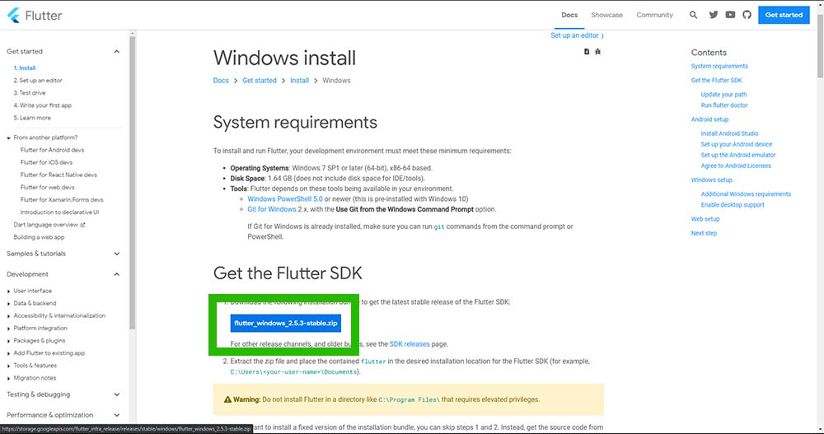

Step 2: Set Environment Variables path.

After downloading the Flutter SDK, extract the file and copy the path of the bin folder.

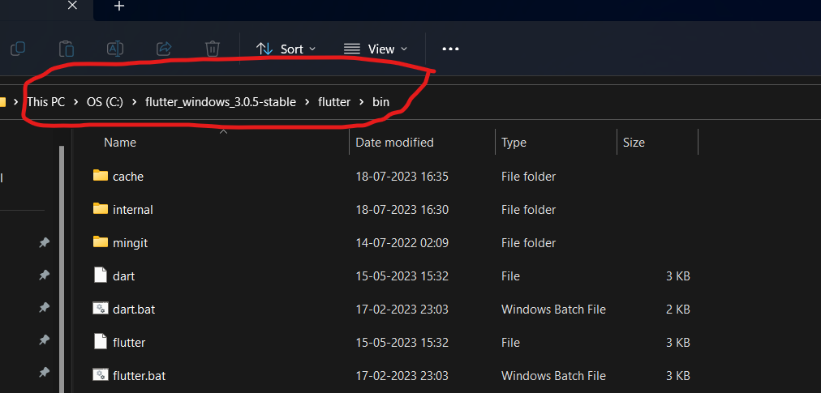

Copy the bin path:

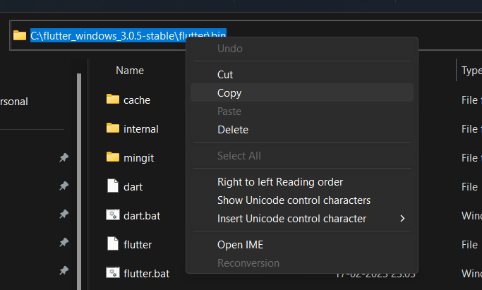

Go to the search bar, and search for **Env.**

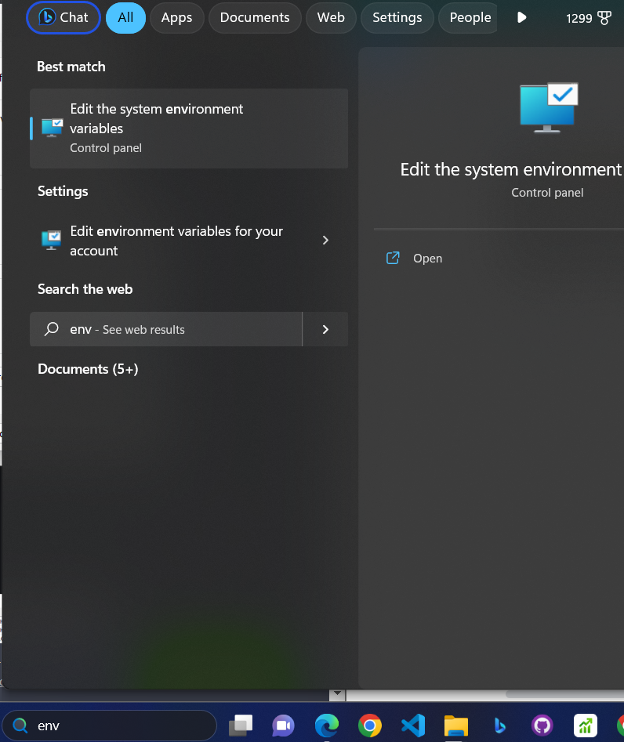

Click on the **Environment Variables.**

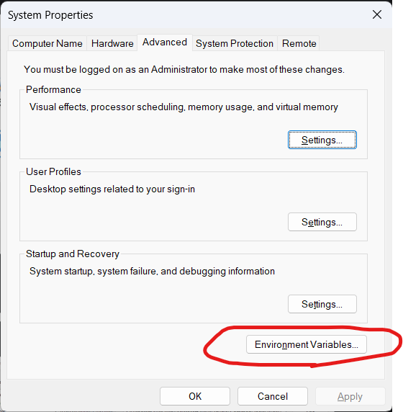

Click on the new and paste the path that was copied earlier and save.

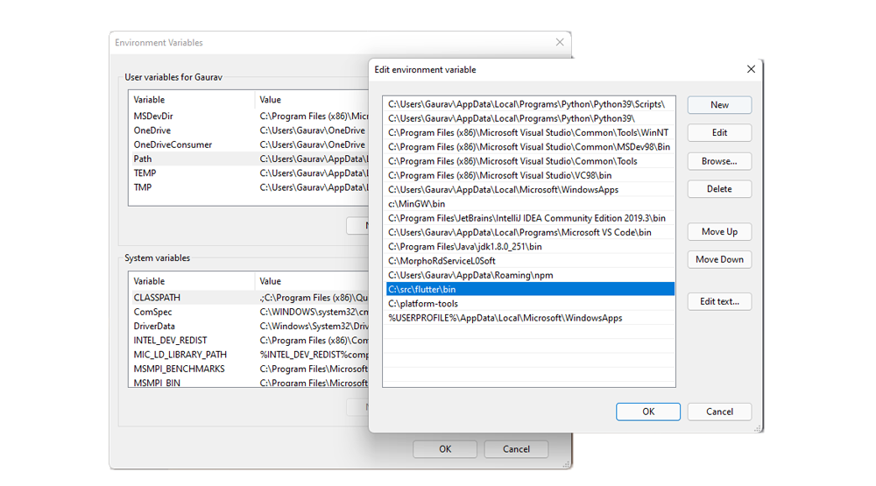

**Step 3:** Installing Flutter in Visual Studio Code.

We have to install two extensions in order to use flutter. The very first extension is **Flutter** and the second is **Dart.** You will be able to find it in Vscode MarketPlace.

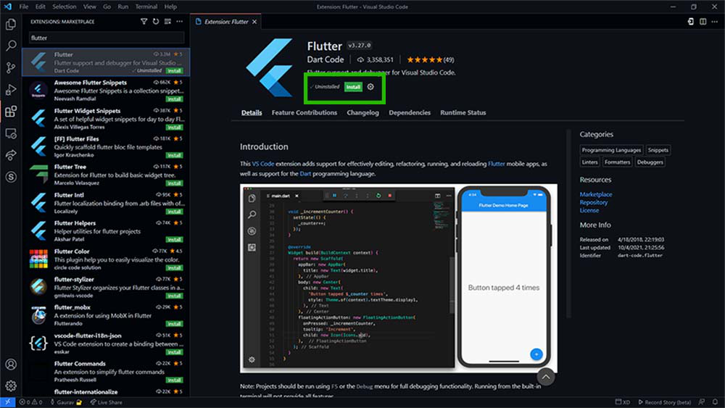

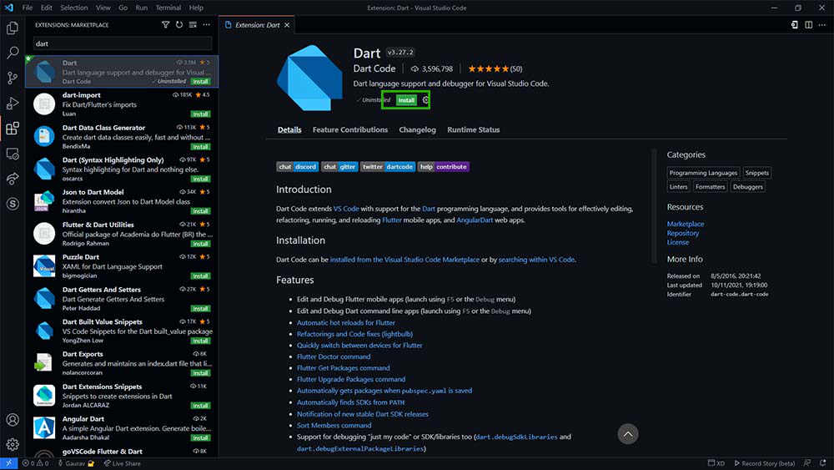

**Step 5:** Now we have successfully added Flutter and Dart to the Visual studio code. Now, let’s check if flutter is installed or not. For this we will open terminal in Visual Studio code and type the following

**“Flutter –version”,**

If everything is fine then it will normally show the version of the installed flutter.

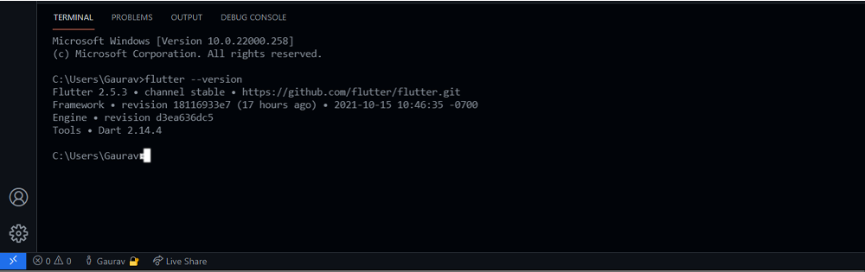

You’ll also need some external packages:

1. Xml:

To install this package run this command on the terminal in project directory to install the dependencies:

**“ flutter pub add xml ”.**

1. Provider:

To install this package run this command on the terminal in project directory to install the dependencies:.

**“ flutter pub add provider ”**

**Step 6:** Open the project in Vscode.

**Step 7:** Open terminal from visual studio menu bar.

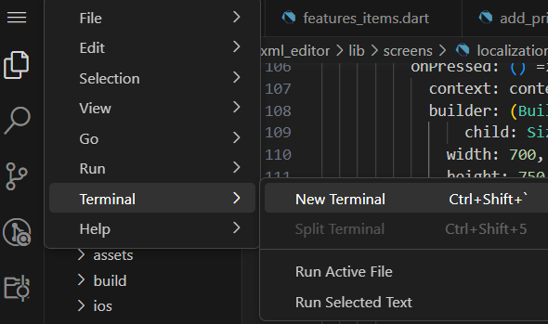

We have to change the directory to the project directory.

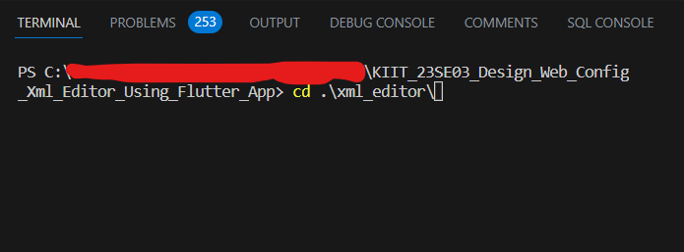

Now, run the program by typing

**“flutter run”**

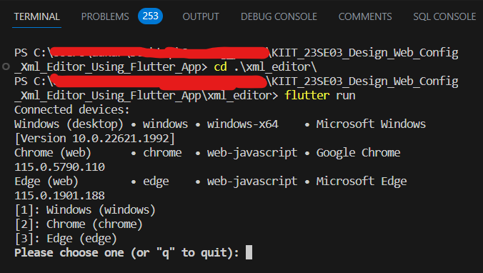

After this command,it will ask where you would like to see the output, now choose for the desired browser by typing 1 or 2.

**Output:** Press 2 to open it in chrome.

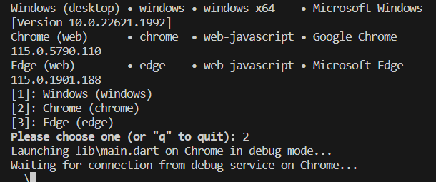

You’ll also need some external packages:

1. Xml:

To install this package run this command on the terminal in project directory to install the dependencies:

**“ flutter pub add xml ”.**

1. Provider:

To install this package run this command on the terminal in project directory to install the dependencies:.

**“ flutter pub add provider ”**

**There’s the app:**

